BASIS DATA 2

Nama : Arifadhil Nurfebrian

PART 3
QUIZZ 1
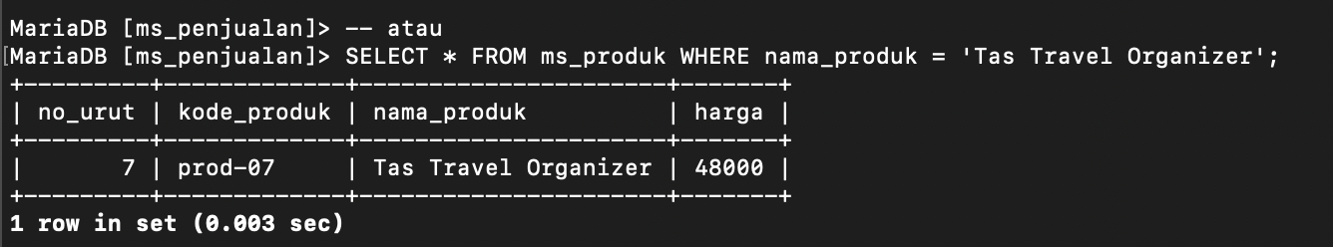

QUIZZ 2
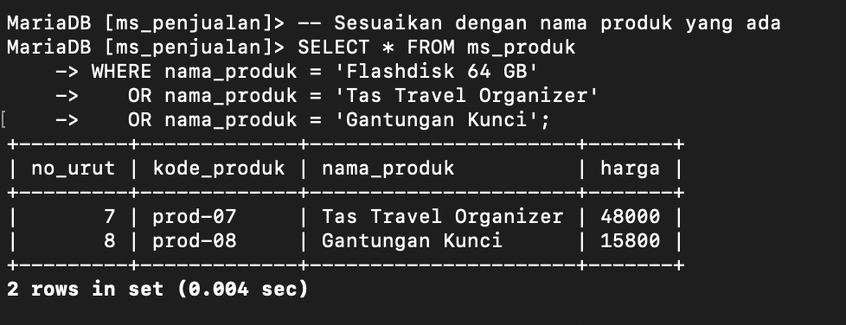

QUIZZ 3
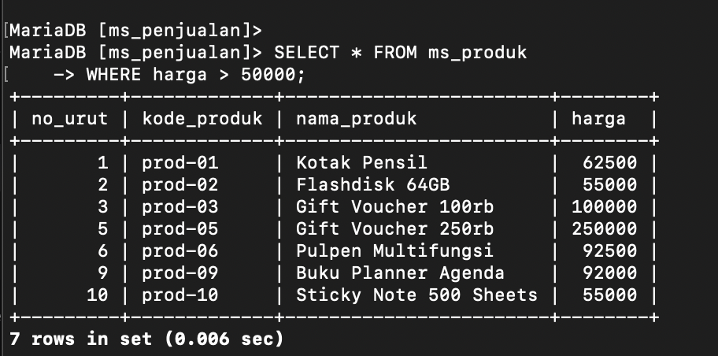
QUIZZ 4
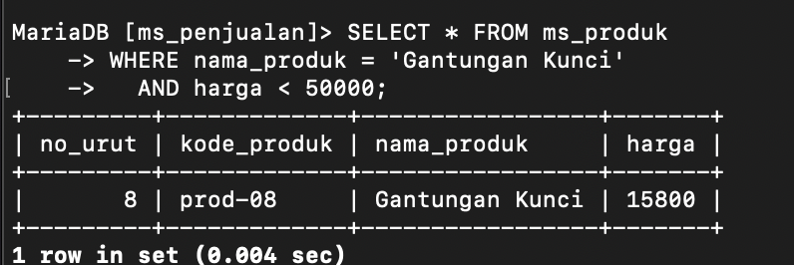

QUIZZ 5
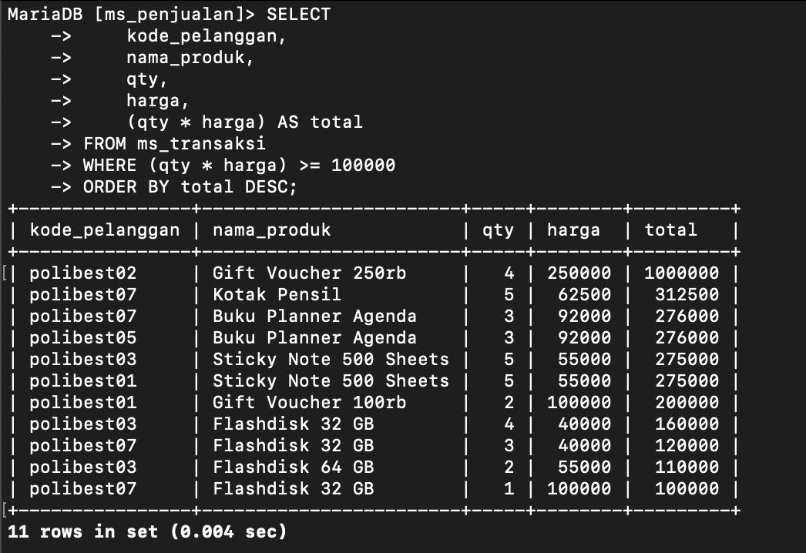

PART 4
QUIZZ 1
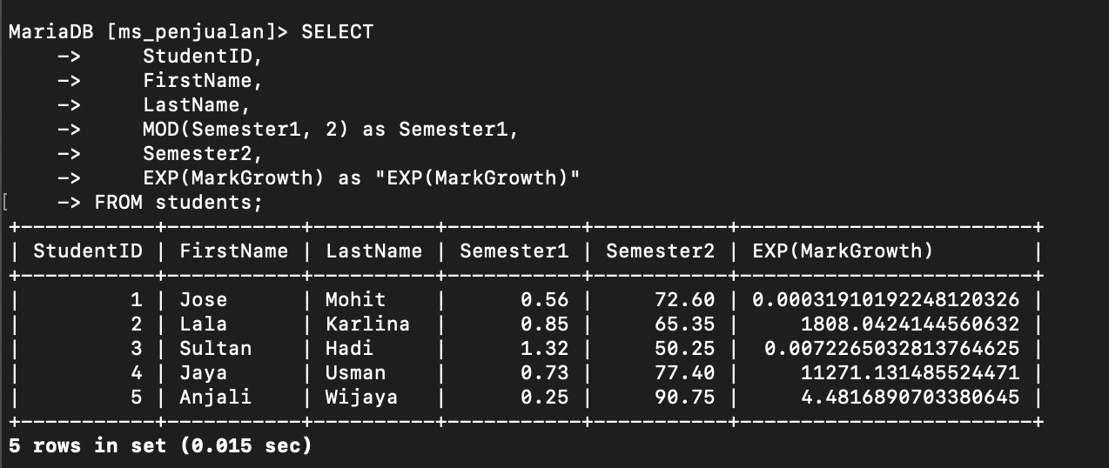

QUIZZ 2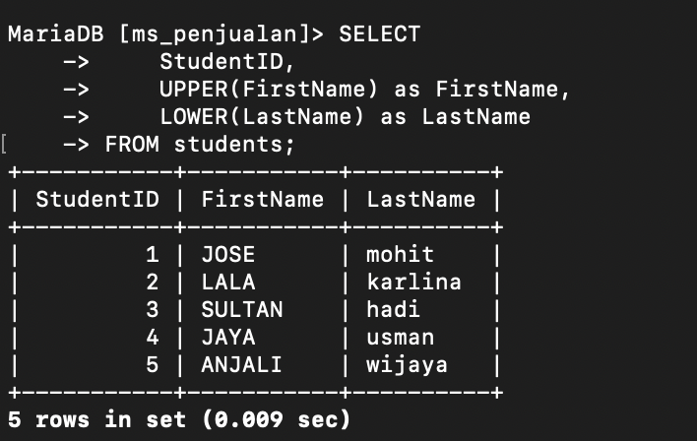

QUIZZ 3
